Announcements – November Diabetes awareness
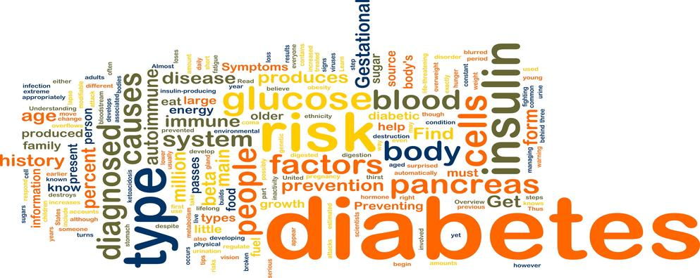

Did you know that diabetes is a serious, chronic disease and that there is no cure for diabetes but diabetes can be managed? Start today by making simple changes in your lifestyle to help prevent you from developing diabetes in the future. Start by choosing healthy foods in your diet and becoming physically active on a regular basis. Our goal is for all youth to learn to make smart healthy choices.

Do you know that you can prevent or delay type 2 diabetes by living a healthy lifestyle which includes being physically active, maintaining a healthy weight, making healthy food choices, and not smoking? Think of ways you can make healthier choices in your life.

Now is the time to start living a healthier lifestyle. Take steps in lowering your chances of developing diabetes. Start by exercising regularly and by eating a balanced diet that includes food from all the food groups. Exercise and proper nutrition are important for everyone.

Being physically active is one of the best ways you can start to lead a healthier lifestyle. Think of ways to increase your exercise, take the stairs, walk or bike to school, join a sports team or club, or participate in intramurals. There are many ways to increase your physical activity. Start today.

Do you eat a healthy diet? This month is diabetes awareness month. One of the ways you can start living a healthier lifestyle is by choosing a healthy diet consisting of all the food groups. It also means decreasing the amount of fat you eat, making alternative choices when eating fast food, and helping around the kitchen to learn how to make healthy foods at home. Start making healthy choices today.

Do you know that exercise and proper nutrition are important for everyone and are particularly important for someone living with diabetes? This month is diabetes awareness month. Start making healthy choices in your life today by incorporating healthy foods into your diet everyday. It can be as simple as bringing healthy snacks to school such as yogurt, fruit and vegetables. Challenge yourself today to live a healthier lifestyle.

